**AZURE DATA BRICKS**

**Day 1 (11-09-2024)**

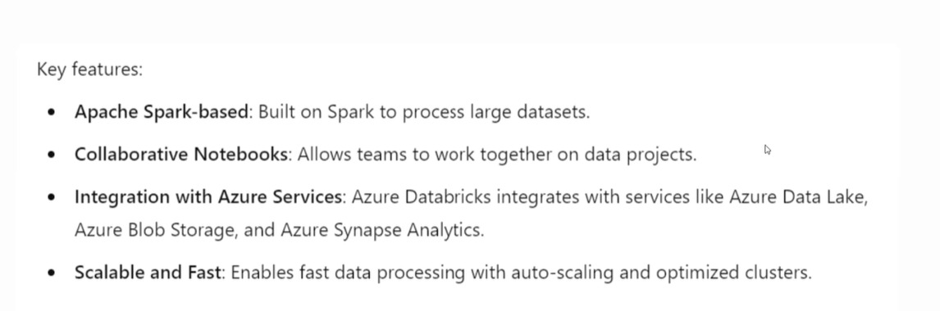

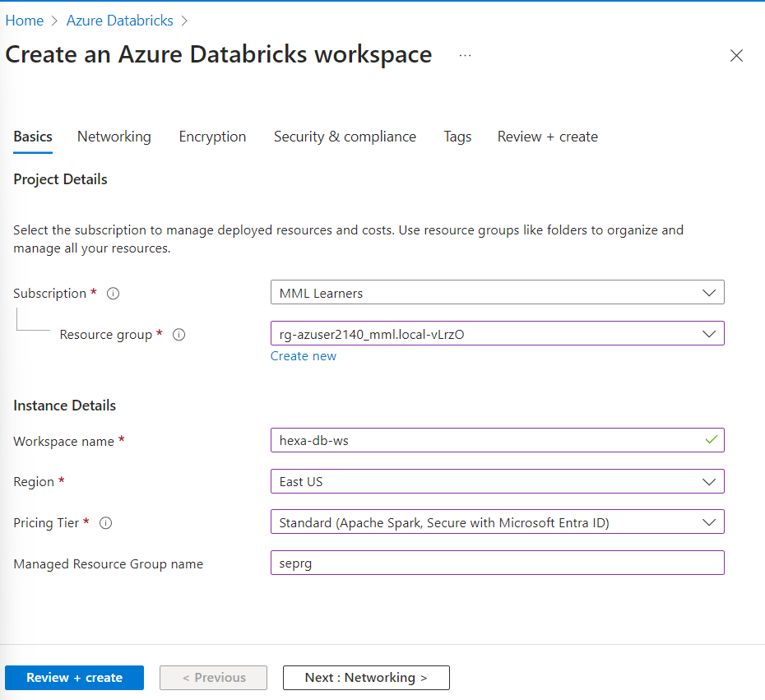

Subscription: MML Learners(company access)

Resource group: default one

Workspace name: preferred name for that brick

Region: should be based on the near location, now it should be default due to access

Pricing Tier: based on access by company

Managed Resource Group name: September rg

**Click review and create,once validation succeeded you are good to go**

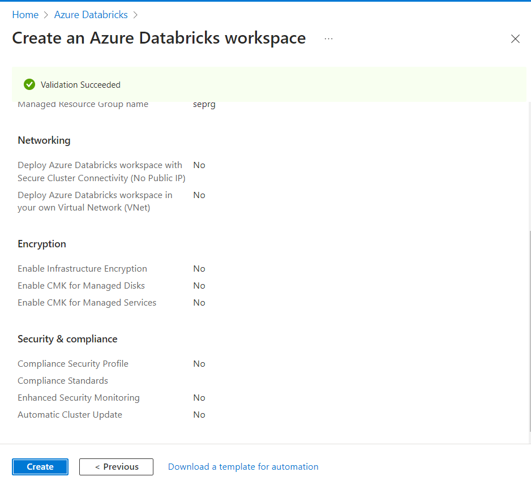

Once u click on create 🡪 deployment will be in progress

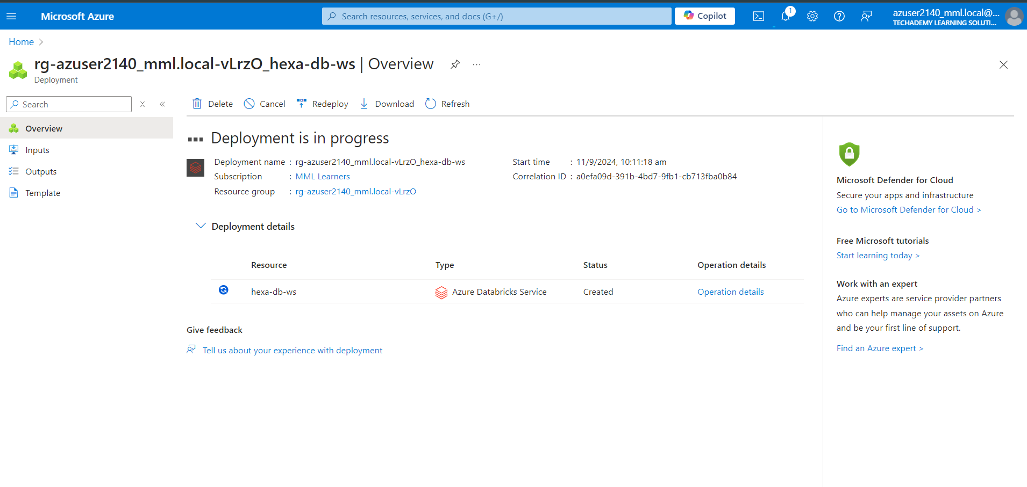

Deploymemt failed

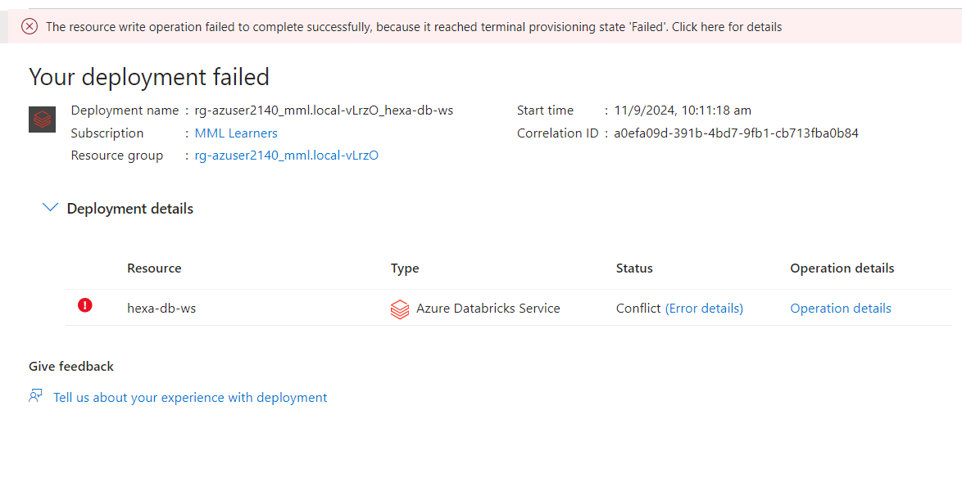

I solved the error by repeating the same process one more time and u need to change managed Resource Group name too so that deployment will be completed  
  
soln:

Repeat the process

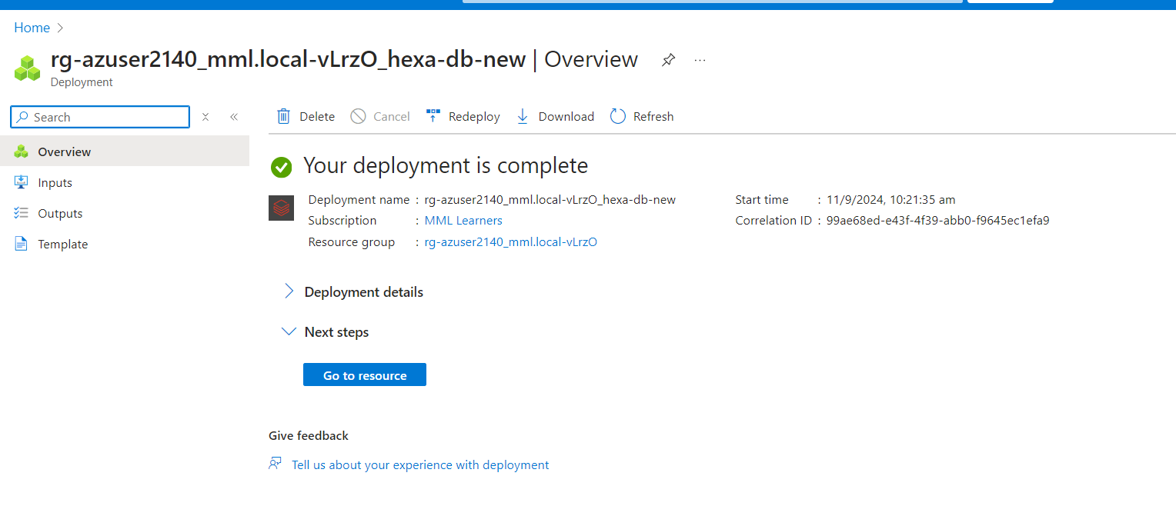

Click go to resource

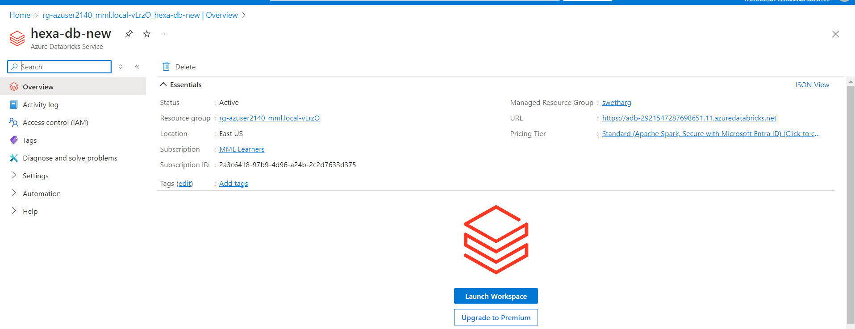

Now launch workspace

After entering pass key

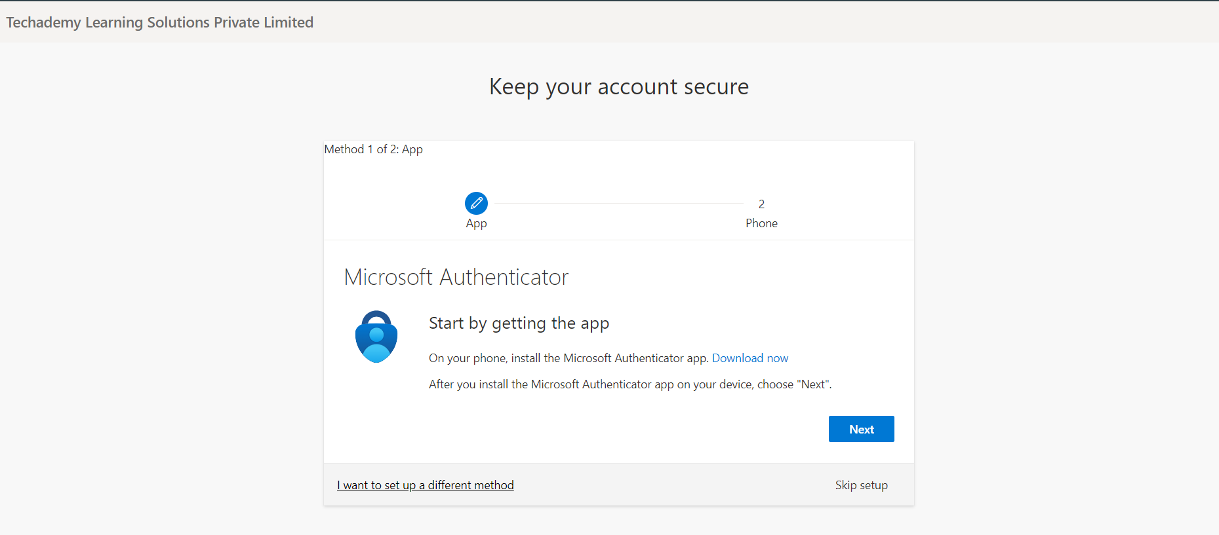

Skip setup

Your workspace will be created

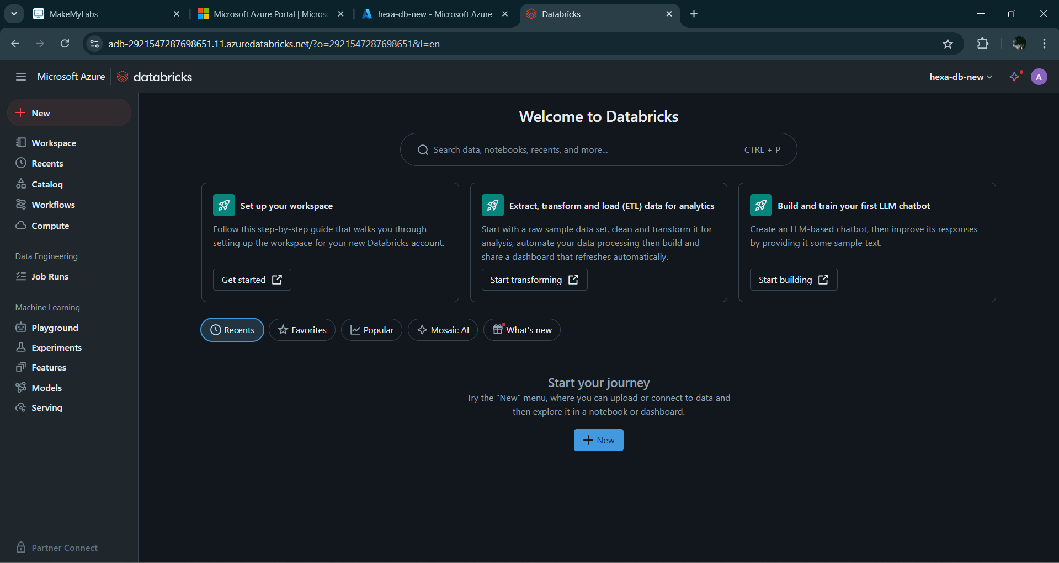

Compute is a virtual machine where we will work with our data so that we are creating our machine by giving specification like how much ram and all

Eg:

Colab 🡪they are providing a environment for running code with pyspark environment ..so apart from colab we need some environment to work apart from google so they choose google over azure

Colab 🡪using free services

Azure 🡪hexaware will pay money

Inside workspace 🡪 compute 🡪 create compute

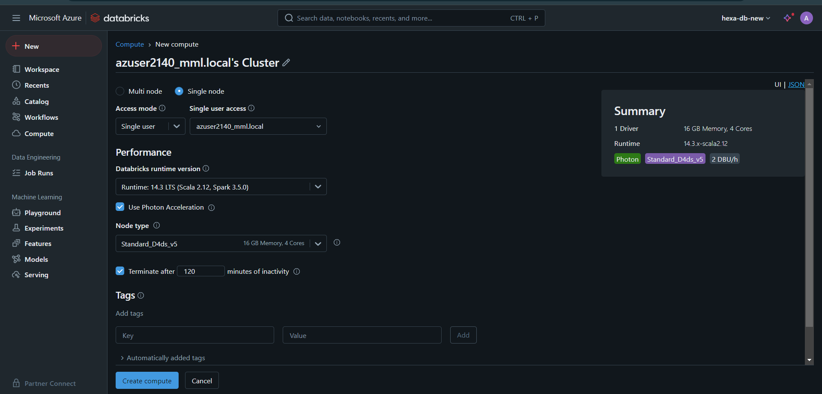

Single node 🡪 one person

Multi node 🡪 shared workspace

User access <-> node type – leave it as default

Nothing to be filled in the region of tags

Then click create compute

It may take some time

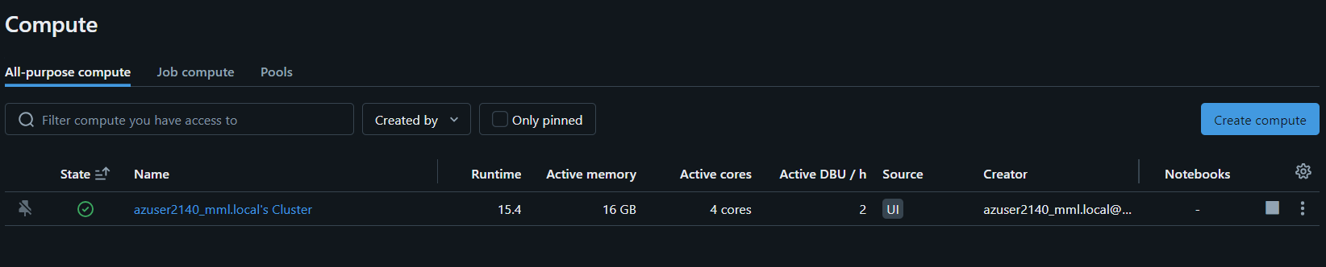

After that u need to create a notebook for that

Go to workspace 🡪 create 🡪notebook

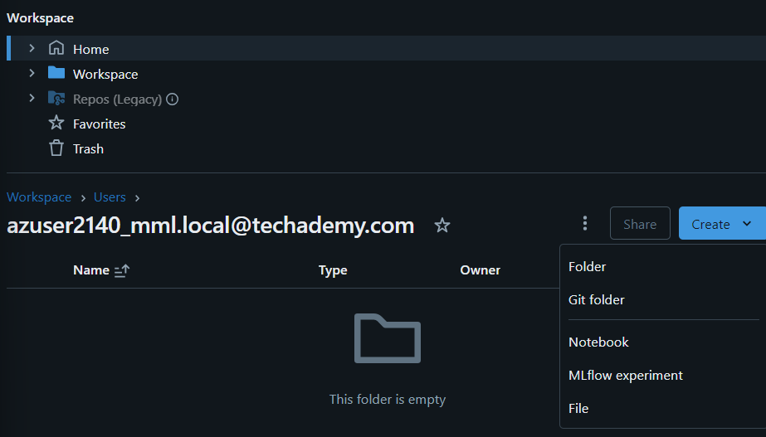

It’s upto u to choose language

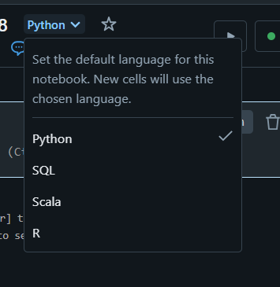

Now u can run code as per requirments

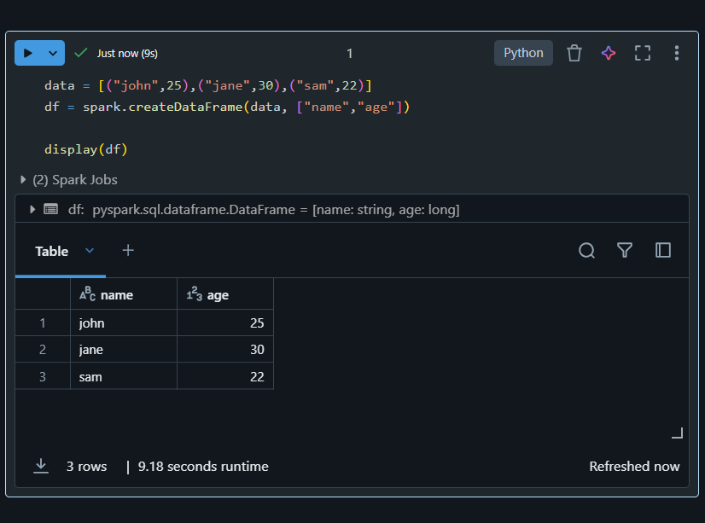

Workspace more similar with google colab

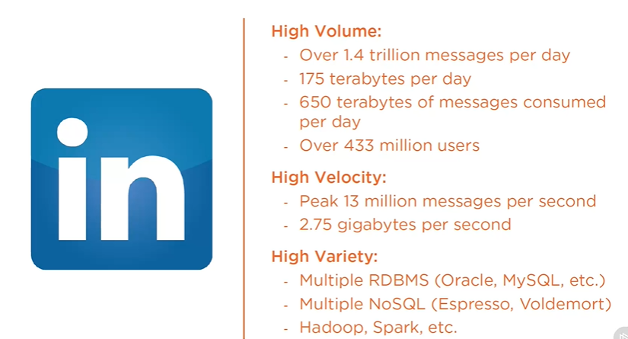

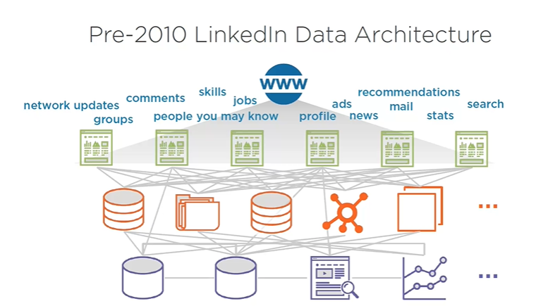

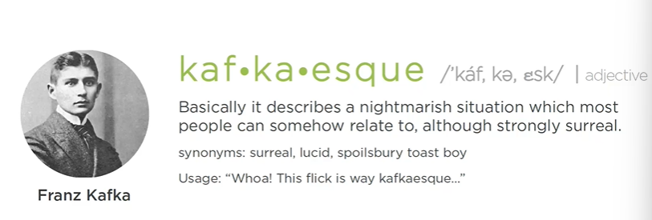

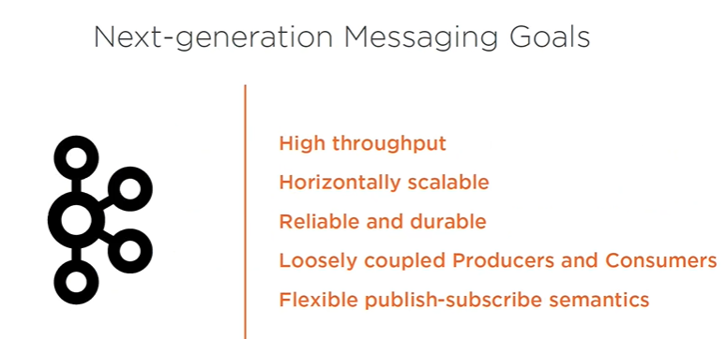

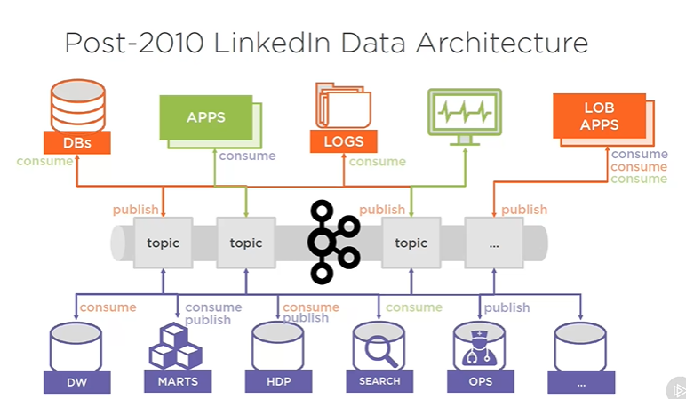kafka way of handling data|^